The Director, Dated:16-12-2025
Skill Development Department,
J&K.

Subject: Casual Leave along with Station Permission.
Sir,
I am writing to request two days of casual leave on 16 and 17 December 2025, along with station permission during this period. I am unable to attend the office due to certain unavoidable personal exigencies that require my presence out of station. During my leave, Mr. Ali Mohd Khan, HOD ECE will look after the Institution.

Thanking you in Anticipation

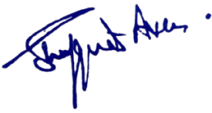
Yours Faithfully

Dr.Shafquat Ara
Principal
Kashmir Government Polytechnic college,
Srinagar

